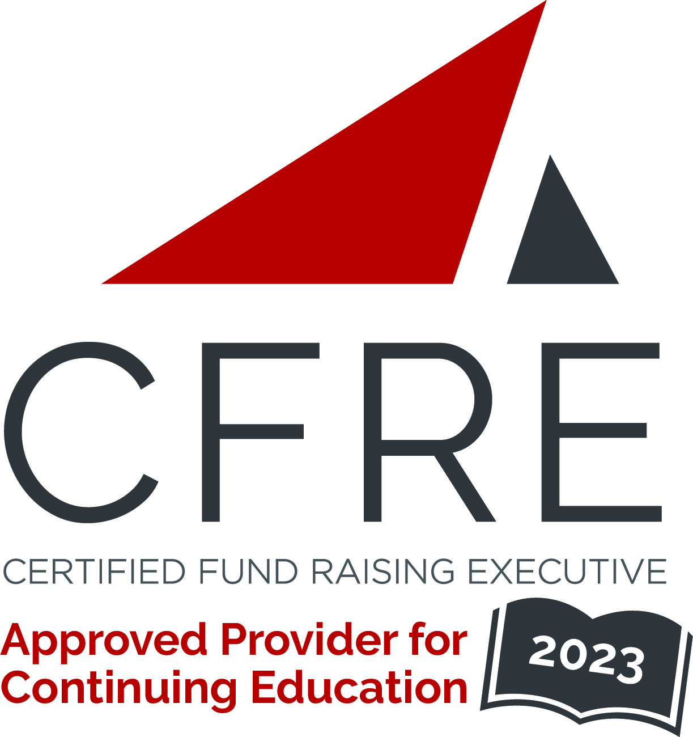  CFRE International has developed this form as a way for you to quickly track (and keep in your files!) the continuing education sessions you have attended. Simply check the boxes next to the sessions you attended. At the end of the conference, add up the total number of hours. Keep this sheet and you will be ready to complete your application form. All of the session slots listed are eligible for continuing education points on your CFRE application for initial certification and/or recertification. Sessions not listed here are not eligible for points. |  | CONTINUING EDUCATION POINTS TRACKER

Activity Organizer: - Meeting of the Minds
Title of Activity: - 2023 Meeting of the Minds Conference
Names of Presenter(s): - Various
Dates and Location: - 8-10 February, 2023 – Pomona, CA USA

Date: 8 February, 2023
Session 1: 2:15pm – 3:30pm (1.25 pts)
- An Introduction to Annual Giving
- CASE Alumni Engagement Metrics
- AI and the Opportunities for Annual Giving

Date: 8 February, 2023
Session 2: 3:45pm – 5:00pm (1.25 pts)
- Life Before Advancement
- A Crowdfunding Forum
- A Donor Wants to Give us What?
- Direct Mail – Tips, Tricks and Tactics

Date: 9 February, 2023
Session 3: 9:00am – 10:15am (1.25 pts)
- A Healthcare Fundraising Forum
- Leadership Annual Giving
- Non-Traditional Roles of Advancement Services Managers
- Best Job on Campus – Why Students Belong in Annual Giving

Date: 9 February, 2023
Session 4: 10:30am – 11:45am (1.25 pts)
- A Community College Fundraising Forum
- A Leadership and Digital Giving Officer Forum
- To Benchmark or Not to Benchmark?
- Fundraising BS: Leveraging Behavioral Science to Drive Donor Conversion Rates

Date: 9 February, 2023
Session 5: 1:00pm – 2:15pm (1.25 pts)
- Forum for Young Professionals in Advancement
- Social Media Advertising and Email Segmentation for Giving Day
- Mystery Science Theater 3000
- DEI Forum

Date: 9 February, 2023
Session 6: 2:30pm – 3:45pm (1.25 pts)
- Women in Advancement Leadership
- The Recurring Riddle of Regular Giving Programs
- IRS (and State) Sticky Wickets
- From Disengaged to Donors

Date: 9 February, 2023
Session 7: 4:00pm – 5:15pm (1.25 pts)
- An Annual Giving Directors’ Discussion
- Staying Remote
- Data Collection, Maintenance, & Integrity Fundamentals

Date: 10 February, 2023
Session 8: 9:00am – 10:15am (1.25 pts)
- Alumni Relations and Annual Giving
- Developing Your Leadership Annual Giving & Major/Planned Gift Prospect Pipeline
- Gift Processing 101

Date: 10 February, 2023
Session 9: 10:30am – 11:45am (1.25 pts)
- The Best of 2022 Annual Giving Idea Exchange
- Using Analytics to Identify, Engage, and Cultivate New Prospects
- Creative Funding Models for Advancement

Date: 10 February, 2023
Session 10: 12:00pm – 1:00pm (1 pt)
- Minds Met: Favorite Take-Aways, Moments of Inspiration and Predictions

Total number of points attained: __________

